Modeling the Annual Cycle of Daily Antarctic Sea Ice Extent
Data Preparation
Before using the data for analysis, I ensured that it was clean and properly formatted. For example, I properly checked for missing values in the "Extent" variable and discovered no missing data in the main dependent variable. The date variables (year, month, and day) were transformed into date objects. The key independent variable was the day of the year variable, which was generated to assist with the main analysis.
Exploratory Data Analysis (EDA)
Exploratory Data Analysis (EDA) was used to identify the data's structure and trends. The Antarctic Sea Ice Extent was measured in million square kilometers and covered the years 1978 to 2023. The early years (1978-1987) contained partial calendar data, with the majority having fewer than 200 data points (out of a possible 366). The year 2023 only had data until April, hence the majority of the data points were not involved. The average Antarctic Sea Ice Extent was 11.585 million square kilometers (with a minimum of 1.766 and a maximum of 20.201). Figure 1 illustrates the overall monthly fluctuation of Antarctic sea ice extent (SIE), which peaked in September and reached its minimum in February. Figure 2 illustrates the years with the greatest and lowest ice extents, which were 1978 and 2023.
Generalized Additive Model (GAM)
A Generalized Additive Model (GAM) was employed to investigate the relationship between sea ice extent (`Extent`) and day of the year (`DayOfYear`) in the Antarctic region. The model, specified as `Extent ~ s(DayOfYear, bs = "cc")`, utilized a cyclic cubic regression spline to flexibly capture the cyclical nature of `DayOfYear` on `Extent`. The model formula Extent ~ s(DayOfYear, bs = "cc") indicated that `Extent' (sea ice extent) was modeled as a function of
Figure 1
Monthly Variation in Antarctic Ice Extent
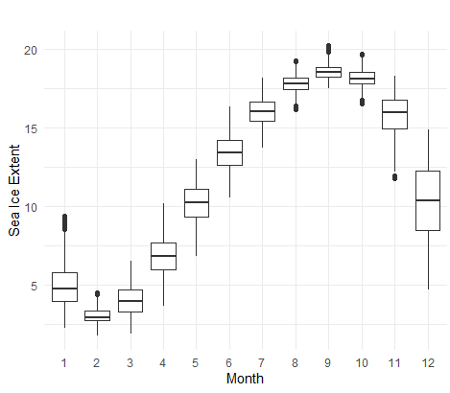

`DayOfYear' using a cubic regression spline (s() function with bs = "cc"). This type of spline is suitable for modeling cyclical or periodic data, such as data that vary with the day of the year, as in the case with Antarctic sea ice extent.
The analysis revealed a highly significant relationship (F(7.991) = 155209, p < .001), indicating that `DayOfYear` significantly influenced `Extent`. The GAM accounted for a substantial portion of the variance in `Extent` (Adjusted R-squared = .988), demonstrating its robust explanatory power. Additionally, the model's Generalized Cross Validation (GCV = .374) and scale estimate (.373) indicated good predictive performance and a reasonable estimate of error variance, respectively. These findings underscored the effectiveness of the
Figure 2
Yearly Average Antarctic Sea Ice Extent
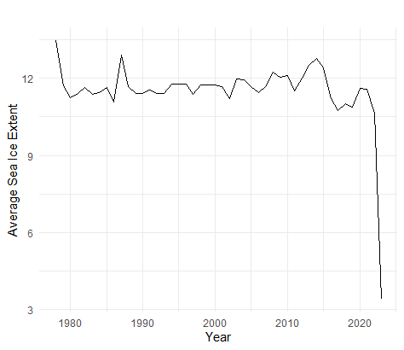
GAM in capturing the complex seasonal dynamics of Antarctic sea ice extent based on day of the year.
The output summary of the linear model fitted with cubic splines for modeling the annual cycle of daily Antarctic sea ice extent is presented in Table 1 below. The coefficients table provides estimates, standard errors, t-values, and p-values for the intercept and each of the spline basis functions. The spline basis functions (e.g., `bs(DayOfYear, df = 12)1`) represented the contributions of the spline terms to the model. Each coefficient estimate showed the effect of that particular spline basis function on the extent. The p-values indicated the statistical significance of each coefficient and most of the spline terms had p-values < .05, indicating that they were statistically significant.
Table 1
Linear Model Fitted with Cubic Splines for Modeling the Annual Cycle of Daily Antarctic Sea Ice Extent
 | B | SE | t | p
(Intercept) | 6.806 | .049 | 140.092 | < .001
`bs(DayOfYear, df = 12)1` | -1.807 | .090 | -20.106 | < .001
`bs(DayOfYear, df = 12)2` | -4.490 | .058 | -77.153 | < .001
`bs(DayOfYear, df = 12)3` | -3.593 | .068 | -52.952 | < .001
`bs(DayOfYear, df = 12)4` | .412 | .058 | 7.115 | < .001
`bs(DayOfYear, df = 12)5` | 4.462 | .062 | 71.897 | < .001
`bs(DayOfYear, df = 12)6` | 8.315 | .060 | 139.576 | < .001
`bs(DayOfYear, df = 12)7` | 10.840 | .061 | 178.118 | < .001
`bs(DayOfYear, df = 12)8` | 11.998 | .061 | 197.814 | < .001
`bs(DayOfYear, df = 12)9` | 11.666 | .063 | 185.359 | < .001
`bs(DayOfYear, df = 12)10` | 8.885 | .070 | 126.539 | < .001
`bs(DayOfYear, df = 12)11` | 2.641 | .074 | 35.650 | < .001
`bs(DayOfYear, df = 12)12` | -.049 | .072 | -.676 | .499
Note: B = coefficient estimates, SE = standard errors, t = t-values, and p = p-values

The cubic spline model appeared to be highly effective in capturing the annual cycle of daily Antarctic sea ice extent, with a high R-squared value and significant coefficients. The model's predictions were accurate on average, with a relatively low residual standard error.
Model Evaluation
In order to evaluate if the model of the annual cycle of daily Antarctic sea ice extent using cyclic cubic regression spline was much better, I compared the performance with the traditional model. The daily, annual cycle of SIE is traditionally calculated by simply taking the average (or the median value) for each day of the year. The Root Mean Square Error (RMSE), widely used metric to measure the differences between predicted values and observed values, was then computed for both models. The RMSE provides a measure of the average magnitude of the errors in a set of predictions, without considering their direction and is the square root of the average of squared differences between prediction and actual observation.
The cross-validated RMSE values for the traditional model and the cubic spline model were as follows: Traditional Model Cross-Validated RMSE = 3.710, Cubic Spline Model Cross-Validated RMSE = .609 (See Figure 3). The traditional model had a much higher cross-validated RMSE compared to the cubic spline model. This indicated that the cubic spline model generalized much better to unseen data, while the traditional model did not perform as well on new data. The cubic spline model was clearly the better choice based on cross-validated RMSE. It provided more accurate predictions on average when evaluated using cross-validation. The traditional model's higher RMSE suggested that it may not be flexible enough to capture the underlying patterns in the data, leading to poorer performance on new data.
Figure 3
Modeled Sea Ice Extent Cycles
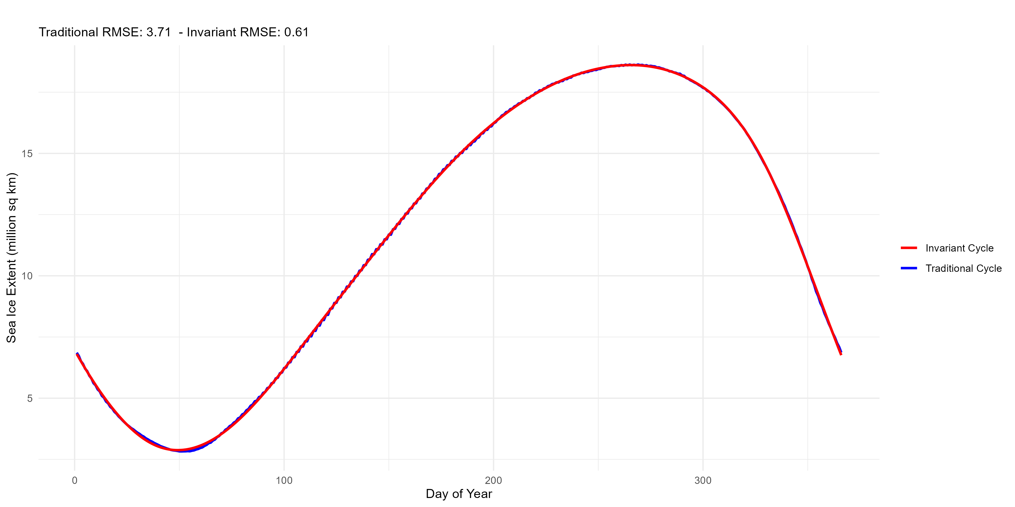
Based on the cross-validated RMSE values, the cubic spline model was the preferred model for predicting the annual cycle of daily Antarctic sea ice extent. It generalized better to new data, providing more accurate predictions. On checking the residuals of the cubic spline model to ensure there were no patterns or biases, I plotted the residuals and checked for homoscedasticity (constant variance of residuals). The plotted areas showed no discernible patterns (See Figure 4)
Figure 4
Residuals of Cubic Spline Model
